Project Management Cycle Log
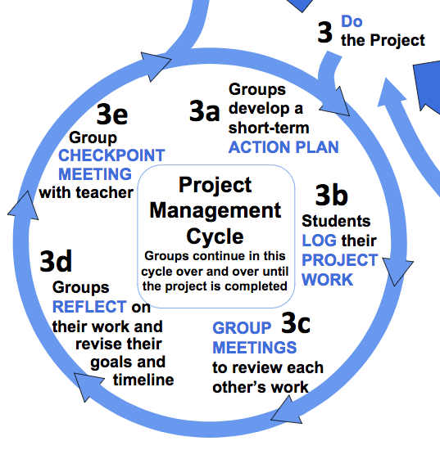

Group #:

Group Members:

Use this template to log your group’s efforts as you work through Project Management Cycles.

You should make some kind of entry every day. This is a living document for your group and your instructors to document, understand, evaluate, reflect, and assist.

Valuable information to record in your Project Log includes:
- Include names on all entries so that it is clear who was contributing
- Notes from research you’re conducting with links to the original material
- Notes of conversations you have had with collaborators and clients
- Logs of what happened during your meetings along with task lists for each of your group members with due dates

Feb 12-18 Log (Project Plan Due 2/12)
- Short-term action plan:

- Weekly Group Meeting (Day = ??)

  - Assignments for each other:

- Daily Log (This should be the long part of the log)

- Reflections on the week:

Initial Meeting w/ Mr. Todd (Feb 19-20)
Agenda (Feel free to add items to this list that you would like to discuss with me):
- Discuss Project Plan
- Discuss group dynamics

Next Steps (You need to put your group’s short term goals here BEFORE we meet):

Teacher suggestions (Please take notes here as we meet so we can keep track of my suggestions to your group):

Assessment (You will assess your group based on the rubric in the “Guidelines” document and I will assess your group):
Project Rubric Score:

Feb 19-25 Log
- Short-term action plan:

- Weekly Group Meeting (Day = ??)

  - Assignments for each other:

- Daily Log (This should be the long part of the log)

- Reflections on the week:

Feb 26-Mar 4 Log
- Short-term action plan:

- Weekly Group Meeting (Day = ??)

  - Assignments for each other:

- Daily Log (This should be the long part of the log)

- Reflections on the week:

CHECKPOINT (Mar 5-6) (Initial Pollinator Garden Design Due)
Agenda:
- Discuss site visit
- Discuss meeting with your client and review your initial garden design.
- Discuss your initial pollinator garden design

Next Steps:

Teacher suggestions:

Assessment:
Project Rubric Score:

Mar 5-11 Log
- Short-term action plan:

- Weekly Group Meeting (Day = ??)

  - Assignments for each other:

- Daily Log (This should be the long part of the log)

- Reflections on the week:

Mar 12-18 Log
- Short-term action plan:

- Weekly Group Meeting (Day = ??)

  - Assignments for each other:

- Daily Log (This should be the long part of the log)

- Reflections on the week:

CHECKPOINT (Mar 19-20)
Agenda:
- Discuss your design revisions and the feedback you got from your advisor

Next Steps:

Teacher suggestions:

Assessment:
Project Rubric Score:

Mar 19-25 Log
- Short-term action plan:

- Weekly Group Meeting (Day = ??)

  - Assignments for each other:

- Daily Log (This should be the long part of the log)

- Reflections on the week:

Mar 26-Apr 1 Log
- Short-term action plan:

- Weekly Group Meeting (Day = ??)

  - Assignments for each other:

- Daily Log (This should be the long part of the log)

- Reflections on the week:

CHECKPOINT (Apr 2-3)
Agenda:
- Discuss your revised pollinator garden design

Next Steps:

Teacher suggestions:

Assessment:
Project Rubric Score:

Apr 2-8 Log
- Short-term action plan:

- Weekly Group Meeting (Day = ??)

  - Assignments for each other:

- Daily Log (This should be the long part of the log)

- Reflections on the week:

Apr 9-15 Log
- Short-term action plan:

- Weekly Group Meeting (Day = ??)

  - Assignments for each other:

- Daily Log (This should be the long part of the log)

- Reflections on the week:

CHECKPOINT (Apr 16-17) (Final Pollinator Garden Design Due April 16th)
Agenda:
- Discuss your your final pollinator garden design

Next Steps:

Teacher suggestions:

Assessment:
Project Rubric Score:

Apr 16-22 Log
- Short-term action plan:

- Weekly Group Meeting (Day = ??)

  - Assignments for each other:

- Daily Log (This should be the long part of the log)

- Reflections on the week:

Apr 23-29 Log
- Short-term action plan:

- Weekly Group Meeting (Day = ??)

  - Assignments for each other:

- Daily Log (This should be the long part of the log)

- Reflections on the week:

CHECKPOINT (Apr 30-May 1)
Agenda:
- Discuss your maintenance guide

Next Steps:

Teacher suggestions:

Assessment:
Project Rubric Score:

Apr 30-May 6 Log
- Short-term action plan:

- Weekly Group Meeting (Day = ??)

  - Assignments for each other:

- Daily Log (This should be the long part of the log)

- Reflections on the week:

May 7-13 Log
- Short-term action plan:

- Weekly Group Meeting (Day = ??)

  - Assignments for each other:

- Daily Log (This should be the long part of the log)

- Reflections on the week:

May 14-20 Log
- Short-term action plan:

- Weekly Group Meeting (Day = ??)

  - Assignments for each other:

- Daily Log (This should be the long part of the log)

- Reflections on the week:

CHECKPOINT (May 21-22)
Agenda:
- Discuss your overall project
- Discuss your webpage

Next Steps:

Teacher suggestions:

Assessment:
Project Rubric Score:

